EOM DIMon 3.1 Installation Instructions for Linux

Bart Heinsius  
December 2, 2016  
Version 3.1.02

# Proposed metadata folder structure:

It is common practice to have separate SAS metadata folders for ETL programs, SAS Reports/SAS Stored Processes, and data. This document assumes installation in the SAS Metadata folder *My Company* shown here:

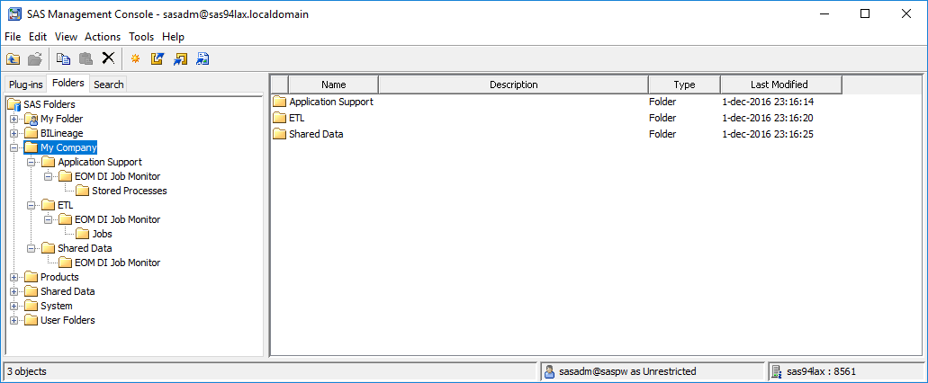

# DIMon Batch Component Installation Instructions

***Important note:*** When copying files from the installation package to the Linux file system, ensure that the files have the Linux file format on the Linux file system (LF as line termination string).

|  |  |
| --- | --- |
| Nr | Instruction |
| 1 | Use SAS Management Console to create a SAS/SHARE or DBMS library with libref DIMON assigned to your SAS DI Application Server to store the DIMon tables. Your batch user needs UPDATE access to the tables in this library. Your SAS General Server User (e.g., sassrv) needs READ access to the tables in this library.  Notes:   * If you use a different libref than "DIMON" for your DIMon tables, add the following line to file "<sasappsrvcontextdir>/BatchServer/autoexec_usermods.sas":  libname dimon (<your libref>); * For MySQL you need the following system variables in my.cnf:  sql_mode='ANSI_QUOTES' # allow " as an identifier quote character (next to backtick) lower_case_table_names=1 # allow case-insensitive table names * For MySQL you need to assign the SAS library to MySQL with PRESERVE_TAB_NAMES=NO * For Postgres please follow instructions for optimization at http://support.sas.com/kb/52/585.html |
| 2 | Create the required tables using the appropriate script for your database provided in the installation package folder "SASBatch\SQL":   |  |  | | --- | --- | | Engine | Script | | SAS/SHARE | dimon_create_tables_sas.sas | | Postgres | dimon_create_tables_postgres.sql | | MySQL | dimon_create_tables_mysql.sql | | MS SQL Server | dimon_create_tables_sqlserver.sql | | Oracle | dimon_create_tables_oracle.sql | |
| 3 | Register the tables that were created in step 2 in SAS metadata folder "/My Company/Shared Data/EOM DI Job Monitor".  **Deselect** the following options when registering the tables:   * Enable case-sensitive DBMS object names * Enable special characters within table or column object name |
| 4 | Import SAS metadata package "SASBatch\SASPackages\dimon-batch.spk" from the installation package to SAS metadata folder "/My Company/ETL/EOM DI Job Monitor/Jobs". Map the tables to the tables you registered in step 3. |
| 5 | Copy all files from installation package folder "SASBatch\SASSteps" to folder "<sasappsrvcontextdir>/SASEnvironment/SASCode/Steps" on your SAS DI Application Server. |
| 6 | Create directory "<sasappsrvcontextdir>/SASEnvironment/SASCode/dimon" on your SAS DI Application Server.  Copy all files from installation package folder "SASBatch\SASCode" to this directory. |
| 7 | Copy files dimon_pre.sh and dimon_post.sh from installation package folder "SASBatch\BatchServer\Linux" to "<sasappsrvcontextdir>/BatchServer" on your SAS DI Application Server.  To help debugging you can set DIMONDEBUG=YES in dimon_pre.sh, which creates the file /tmp/dimon-debug.txt containing a list of environment variables. |
| 8 | Make a backup copy of file "<sasappsrvcontextdir>/BatchServer/sasbatch.sh" on your SAS DI Application Server. |
| 9 | Edit <sasappsrvcontextdir>/BatchServer/sasbatch.sh on your SAS DI Application Server:  Insert before line:  exec "$SAS_COMMAND" -noxcmd -lrecl 32767 "$@" "${USERMODS_OPTIONS[@]}"  the following lines:  # EOM DI Monitor - prolog -- begin  . $APPSERVER_ROOT/BatchServer/dimon_pre.sh  # EOM DI Monitor - prolog – end  Insert after line:  exec "$SAS_COMMAND" -noxcmd -lrecl 32767 "$@" "${USERMODS_OPTIONS[@]}"  the following lines:  # EOM DI Monitor - epilog -- begin  JOB_RC=$?  . $APPSERVER_ROOT/BatchServer/dimon_post.sh  exit $JOB_RC  # EOM DI Monitor - epilog – end  replace line:  exec "$SAS_COMMAND" -noxcmd -lrecl 32767 "$@" "${USERMODS_OPTIONS[@]}"  with  "$SAS_COMMAND" -noxcmd -lrecl 32767 "$@" -log "$SASLOGFILE" -print "$SASLSTFILE" "${USERMODS_OPTIONS[@]}" |
| 10 | Add the following line to file "<sasappsrvcontextdir>/BatchServer/autoexec_usermods.sas":  options fullstimer; |
| 11 | Check to see whether the APPSERVER_ROOT environment variable is available in your SAS batch programs. You can do this by submitting the following SAS code on your SAS DI Application Server:  %put %sysget(APPSERVER_ROOT);  If you see a valid path in the log, you're done with this step.  If you see the following message in the log:  WARNING: The argument to macro function %SYSGET is not defined as a system variable.  Then add the following line to file "<sasappsrvcontextdir>/appservercontext_env_usermods.sh":  export APPSERVER_ROOT |
| 12 | Using SAS DI Studio, run DI Studio job "/My Company/ETL/EOM DI Job Monitor/Jobs/DIMon_Load_Flows_and_Jobs" that you imported in step 4, on your SAS DI Application Server.  You can ignore the warning that there are transformations that may be out of order in the job. |
| 13 | Deploy the SAS DI Studio jobs imported in step 4 for scheduling on your SAS DI Application Server.  Use the SAS Management Console Schedule Manager plug-in to create a flow with the following deployed jobs:   1. DIMon_Load_Flows_and_Jobs 2. DIMon_Statistics     Schedule the flow to run daily, as the first step in your nightly batch. |
| -- END OF INSTRUCTIONS DIMON BATCH COMPONENT | |

# DIMon Web Application Installation Instructions

|  |  |
| --- | --- |
| Nr | Instruction |
| 1 | Import SAS metadata package "Webapp\SASPackages\dimon-webapp.spk" into SAS metadata folder "/My Company/Application Support/EOM DI Job Monitor/Stored Processes". Assign the Stored Processes to run on your SAS Web Application Server (if you have that). |
| 2 | Copy the content of folder "Webapp\Webapps" to directory "<SASConfigDir>/Web/WebServer/htdocs/" on your SAS Web Application Server. |
| 3 | Copy the content of folder "Webapp\SASMacro" to directory "<sasappsrvcontextdir>/SASEnvironment/SASMacro" on your SAS Web Application Server. |
| 4 | Edit file "<sasappsrvcontextdir>\SASEnvironment\SASMacro\dimon_init.sas" on your SAS Web Application Server and update the settings/paths:   |  |  |  | | --- | --- | --- | | Setting | Description | Default value | | sproot | Folder where dimon-webapp.spk was imported to | /My Company/Application Support/EOM DI Job Monitor/Stored Processes | | webroot | Relative URL path to where the webapps components were copied to in step 2 | /eom/dimon |   If you use a different libref than "DIMON" for your DIMon tables, set that in the section marked yellow below:  %if (%sysfunc(libref(dimon)) ne 0) %then  %do; /* assign dimon library */  %put NOTE: Assigning library DIMON;  libname dimon (dimonsas);  %end;/* assign dimon library */  libname dimon list; |
| 5 | If you chose a different metadata location in Step 1 than the default ("/My Company/Application Support/EOM DI Job Monitor/Stored Processes"), update file "<SASConfigDir>/Web/WebServer/htdocs/eom/dimon/index.html" to reflect that in the sections marked yellow below: |
| 6 | Start the EOM DI Job Monitor web application by navigating your browser to <http://your-sasweb-server:7980/eom/dimon/> . If you don’t have any flows scheduled yet you should see the following: |
| -- END OF INSTRUCTIONS DIMON WEB APPLICATION COMPONENT | |